Pepper
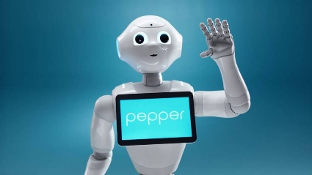 | Pepper, like Zora, is a humanoid robot. This means that it has a human form. Pepper can be used for all kinds of functions. In healthcare, Pepper is often used as a social robot to activate and entertain residents. Pepper has facial recognition and speech recognition and can communicate with clients via speech and through the screen on his stomach.
Zora
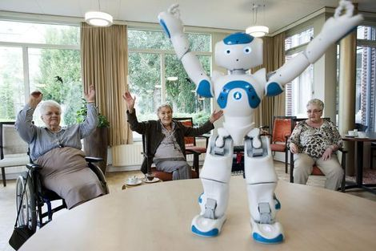 | Zora is a small humanoid care robot. This means that the robot has a human form. Zora is mainly used during exercise activities, for example during rehabilitation. Zora can also entertain clients: she can dance, read stories and play games. Zora is mainly used in groups.
Tessa
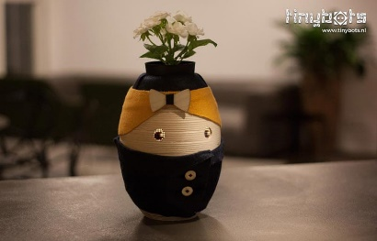 | Tessa is a social robot that helps clients to apply structure in daily life. She reminds clients of small tasks and planned appointments. Tessa tells us what the agenda looks like and makes suggestions for activities such as coffee drinking. Tessa can also play personal music.
Paro
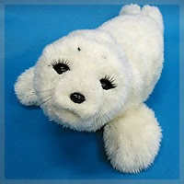 | Paro is a seal robot that can be used for relaxation and therapeutic purposes. The hugging robot stimulates interaction and ensures peace or activity. Through the sensors under his coat, he responds to sound, touch and movement.

Robotrollator Lea

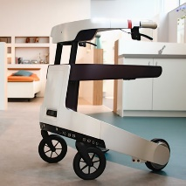 | Robot Lea is a walker and a personal assistant in one. She helps clients get out of bed or in a chair and keeps them active. In addition, clients can communicate with a tablet via LEA and receive reminders to, for example, take medication.
Robot arm Obi

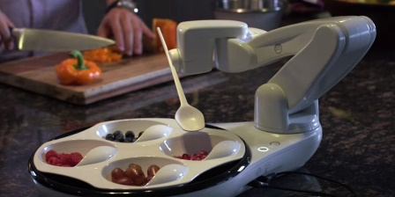 |  | Obi is a robotic arm that can bring food to the mouth of a client. This makes it easier for clients to decide for themselves what, when and how fast they want to eat. This is because they are no longer dependent on the help of a healthcare professional.
Robotcat Joy for all

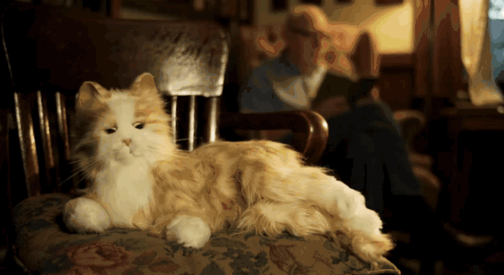 |  | The robot cat Joy for All looks like a real cat through its soft fur. She meows, spins and responds to touches. Suitable for elderly people with dementia and lonely elderly.
Qbi

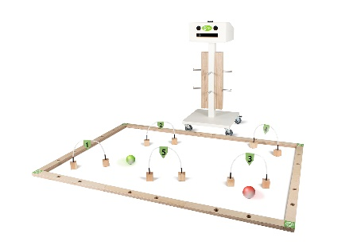 |  | Qbi challenges people in an approachable way to move. With body movements, clients can control a ball without touching it. For example, older people can play all sorts of games and do exercises that are good for balance and coordination and fun to do.
Smart electronics

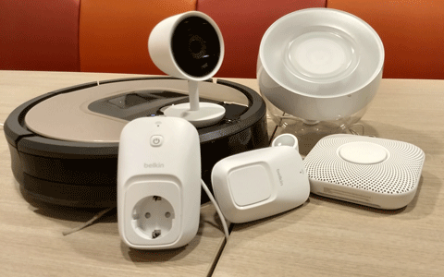 |  | Devices in the house are getting smarter. Think of a robotic vacuum cleaner, a smart lighting meter, a security camera or a motion sensor. You can also link these devices together. For example, a security camera and a light sensor on a robot vacuum cleaner, so that the vacuum cleaner will do its work if there is nobody in the room.
JustoCat

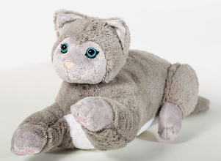 |  | The JustoCat has been developed as an alternative to real pets. He has the same size, the same weight, spins and meows and responds to touches. JustoCat evokes positive memories, making dementia feel better.

