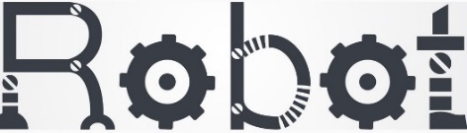
Human
versus



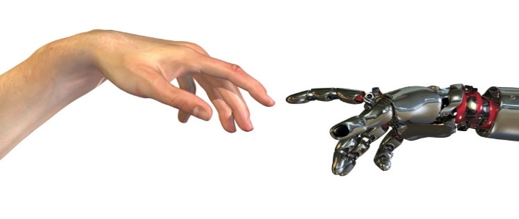
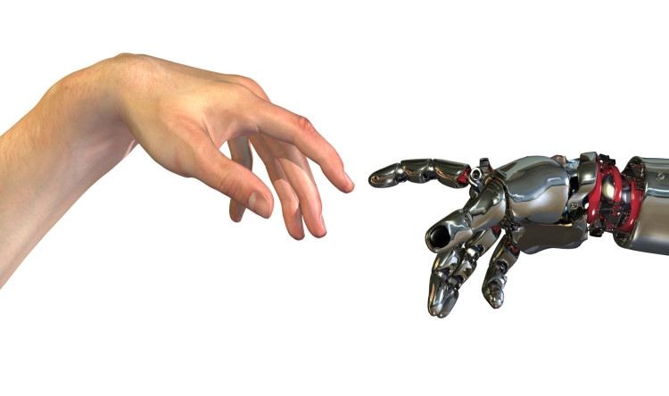
Name:
……………………………………………………………
- If I can create a robot it would be this and I would give it/him/her this name:
…………………………………………………………………………………………………………………….…
………………………………………………………………………………………………………………………..
………………………………………………………………………………………………………………………..
………………………………………………………………………………………………………………………..

- I would like to be friends with a robot.
( Yes / No )

- You cannot have a (friendly) relationship with a robot, because it feels nothing.
( Agree / Disagree )

- Can robots feel love?
( Yes / No )

- We will always be smarter than robots.
( Agree / Disagree )

- Would you like to date with a robot?

( Yes / No )
- Draw your own robot? What does it looks like? Friendly, technical, big, small, … What can the robot do for you? Who is the robot in contact with? Etcetera …

- Complete the following sentence:
In 50 years, people and robots will …

…………………………………………………………………………………………………………………….…
………………………………………………………………………………………………………………………..
………………………………………………………………………………………………………………………..
………………………………………………………………………………………………………………………..
…………………………………………………………………………………………………………………….…
………………………………………………………………………………………………………………………..
………………………………………………………………………………………………………………………..
………………………………………………………………………………………………………………………..
…………………………………………………………………………………………………………………….…
………………………………………………………………………………………………………………………..

If you could be 90 years old and have to choose whether you have the body or brains of a 30-year-old for the last 60 years of your life, what would you choose?
O The body of a 30-year-old
O The brains of a 30-year-old

Mention 3 things that you and and robot have in common:

- …………………………………………………………………………………………………………..
………………………………………………………………………………………………………………………………………………………………………………………………………………………..
……………………………………………………………………………………………………………
- …………………………………………………………………………………………………………..
………………………………………………………………………………………………………………………..……………………………………………………………………………………………………………………………………………………………………………………………………………

- …………………………………………………………………………………………………………..
………………………………………………………………………………………………………………………………………………………………………………………………………………………..
……………………………………………………………………………………………………………

If you wake up tomorrow with a robot super power, which power would you like to have?

.……………………………………………

What is for you most important in friendship? Can you have the same with a robot?
…………………………………………………………………………………………………………………….…
………………………………………………………………………………………………………………………..
………………………………………………………………………………………………………………………..
………………………………………………………………………………………………………………………..
………………………………………………………………………………………………………………………..

As a technology, just like a glass sphere, you could tell everything about your future. Would you like to know what could happen? What do you want to know? (Or not?)

Can robots experience love and affection?
…………………………………………………………………………………………………………………….…
………………………………………………………………………………………………………………………..
………………………………………………………………………………………………………………………..
………………………………………………………………………………………………………………………..

Which technological device in your life do you care about the most?
…………………………………………………………………………………………………………………….…
………………………………………………………………………………………………………………………..
………………………………………………………………………………………………………………………..
………………………………………………………………………………………………………………………..

Wich movie, documentary or YouTube video about technology (and care) would you recommend to others?
Title: ……………………………………..………………………………………………………………………..
Link: ………………………………………………………………………………………………………………..

What rating do you give current technology in healthcare?
(circle the number)

1 2 3 4 5 6 7 8 9 10
What name would you give the robot in the image below? And what would you prefer that it/he/she is able to do?

